Name: Areeb Ansari Roll No:A3-B1-01
Practical 5
Aim: Implement a dynamic algorithm for Longest Common Subsequence (LCS) to find the
length and LCS for DNA sequences.

Problem Statement:
(i) DNA sequences can be viewed as strings of A, C, G, and T characters, which
represent nucleotides. Finding the similarities between two DNA sequences are an
important computation performed in bioinformatics.

[Note that a subsequence might not include consecutive elements of the original sequence.]

TASK 1: Find the similarity between the given X and Y sequence.
X=AGCCCTAAGGGCTACCTAGCTT
Y= GACAGCCTACAAGCGTTAGCTTG
Output: Cost matrix with all costs and direction, final cost of LCS and the LCS.
Length of LCS=16
Code:
#include <stdio.h>
#include <string.h>

int lcs(char *X, char *Y, int m, int n) {
int L[m+1][n+1];
char dir[m+1][n+1];

for (int i = 0; i <= m; i++) {
for (int j = 0; j <= n; j++) {
if (i == 0 || j == 0) {
L[i][j] = 0;
dir[i][j] = '0';
}
else if (X[i-1] == Y[j-1]) {
L[i][j] = L[i-1][j-1] + 1;
dir[i][j] = 'D'; // Diagonal ↖
}
else if (L[i-1][j] >= L[i][j-1]) {
L[i][j] = L[i-1][j];
dir[i][j] = 'U'; // Up ↑
}
else {
L[i][j] = L[i][j-1];
dir[i][j] = 'L'; // Left ←
}
}
}

printf("\nDP Table with directions:\n");
for (int i = 0; i <= m; i++) {
for (int j = 0; j <= n; j++) {
if (dir[i][j] == 'D') printf("D ");
else if (dir[i][j] == 'U') printf("U ");
else if (dir[i][j] == 'L') printf("L ");
else printf("0 ");
}
printf("\n");
}

int index = L[m][n];
char lcsStr[index + 1];
lcsStr[index] = '\0';

int i = m, j = n;
while (i > 0 && j > 0) {
if (X[i-1] == Y[j-1]) {
lcsStr[index-1] = X[i-1];
i--; j--; index--;
}
else if (L[i-1][j] >= L[i][j-1]) {
i--;
}
else {
j--;
}
}

printf("\nLCS string is: %s\n", lcsStr);
return L[m][n];
}

int main() {
char X[] = "AGCCCTAAGGGCTACCTAGCTT";
char Y[] = "GACAGCCTACAAGCGTTAGCTTG";
int m = strlen(X);
int n = strlen(Y);

printf("Length of LCS is %d\n", lcs(X, Y, m, n));
return 0;
}

Output:
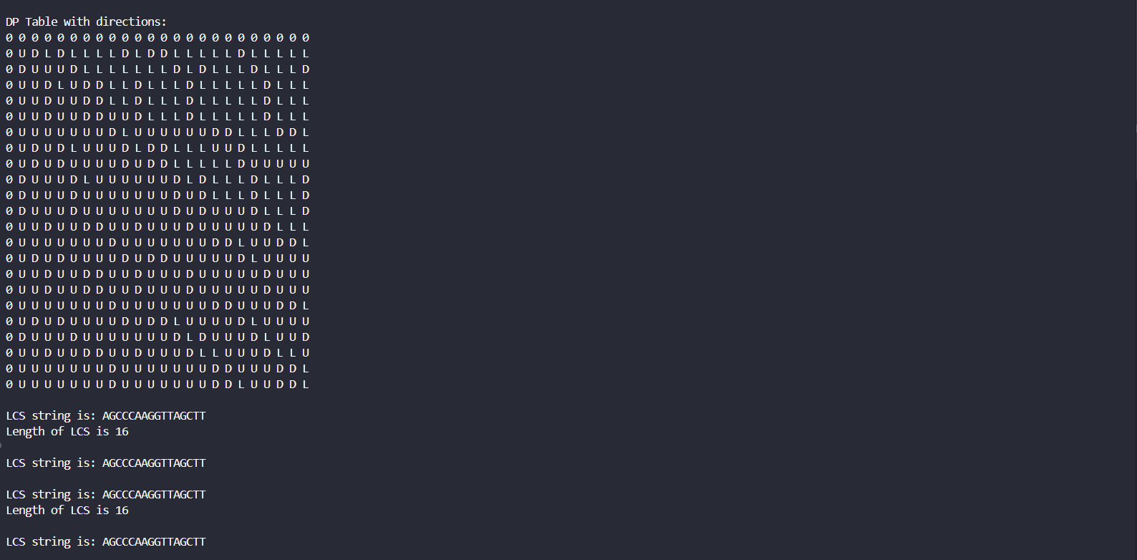

TASK-2: Find the longest repeating subsequence (LRS). Consider it as a variation of the
longest common subsequence (LCS) problem.
Let the given string be S. You need to find the LRS within S. To use the LCS framework, you
effectively compare S with itself. So, consider string1 = S and string2 = S.
Example:
AABCBDC
LRS= ABC or ABD
Code:
#include <stdio.h>
#include <string.h>

int lrs(char *str, int n) {
int L[n+1][n+1];

for (int i = 0; i <= n; i++) {
for (int j = 0; j <= n; j++) {
if (i == 0 || j == 0) {
L[i][j] = 0;
}
else if (str[i-1] == str[j-1] && i != j) {
L[i][j] = 1 + L[i-1][j-1];
}
else {
L[i][j] = (L[i-1][j] > L[i][j-1]) ? L[i-1][j] : L[i][j-1];
}
}
}

int index = L[n][n];
char lrsStr[index + 1];
lrsStr[index] = '\0';

int i = n, j = n;
while (i > 0 && j > 0) {
if (L[i][j] == L[i-1][j-1] + 1 && str[i-1] == str[j-1] && i != j) {
lrsStr[index - 1] = str[i-1];
i--;
j--;
index--;
}
else if (L[i-1][j] > L[i][j-1]) {
i--;
}
else {
j--;
}
}

printf("Longest Repeated Subsequence is: %s\n", lrsStr);
return L[n][n];
}

int main() {
char str[] = "AAABCBDC";
int n = strlen(str);

printf("Length of LRS is %d\n", lrs(str, n));
return 0;
}

Output:
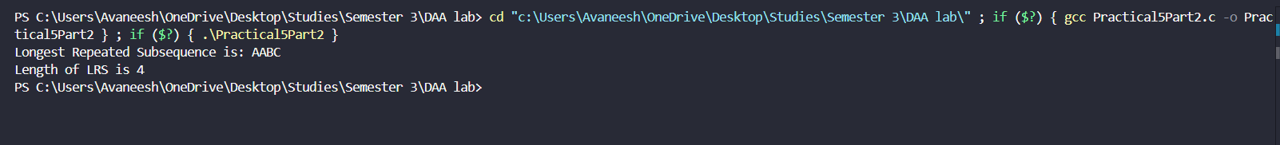

LeetCode:
#include <stdio.h>
#include <string.h>
#include <stdlib.h>

int longestCommonSubsequence(char* text1, char* text2) {
int m = strlen(text1);
int n = strlen(text2);

int **dp = (int **)malloc((m+1) * sizeof(int *));
for (int i = 0; i <= m; i++) {
dp[i] = (int *)malloc((n+1) * sizeof(int));
}

for (int i = 0; i <= m; i++) {
for (int j = 0; j <= n; j++) {
if (i == 0 || j == 0) {
dp[i][j] = 0;
}
else if (text1[i-1] == text2[j-1]) {
dp[i][j] = 1 + dp[i-1][j-1];
}
else {
dp[i][j] = (dp[i-1][j] > dp[i][j-1]) ? dp[i-1][j] : dp[i][j-1];
}
}
}
int result = dp[m][n];

for (int i = 0; i <= m; i++) {
free(dp[i]);
}
free(dp);

return result;
}

int main() {
char text1[] = "abcde";
char text2[] = "ace";
printf("Length of LCS = %d\n", longestCommonSubsequence(text1, text2));
return 0;
}
